Name : Mriganka Patra

Email – [mriganka.patra@cognizant.com](mailto:mriganka.patra@cognizant.com)

Emp id - 2415820

Assignment 1:

Salesforce CRM – List Views, Workflows, Validation and Security

Objective:

Apply Advanced features of Salesforce such as creating list views, implementing automation via workflows, and enforcing data integrity and security rules.

Tasks:

1. Create a list view for the “Project” object to display all records with a ‘Status’ in progress
2. Define a workflow process to automatically send an email when a projects status is updated to ‘complete’
3. Create a validation rule to ensure ‘End Date’ is always after ‘Start Date’
4. Set field-level security to restrict access to the ‘Budget’ field for a specific profile
5. Configure Object-level permissions to control create , read and edit rights for the ‘ Project Object’

Deliverables:

* Configures of list views and workflows
* Validation rule logic and test result
* Security settings applied with profile details

Task 1: Create a list view for the “Project” object to display all records with a ‘Status’ in progress

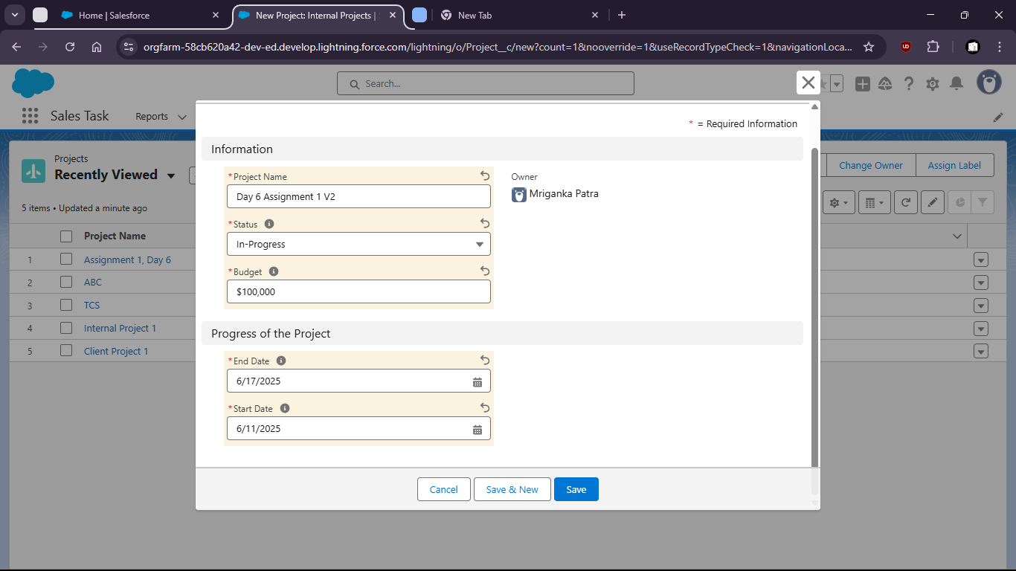

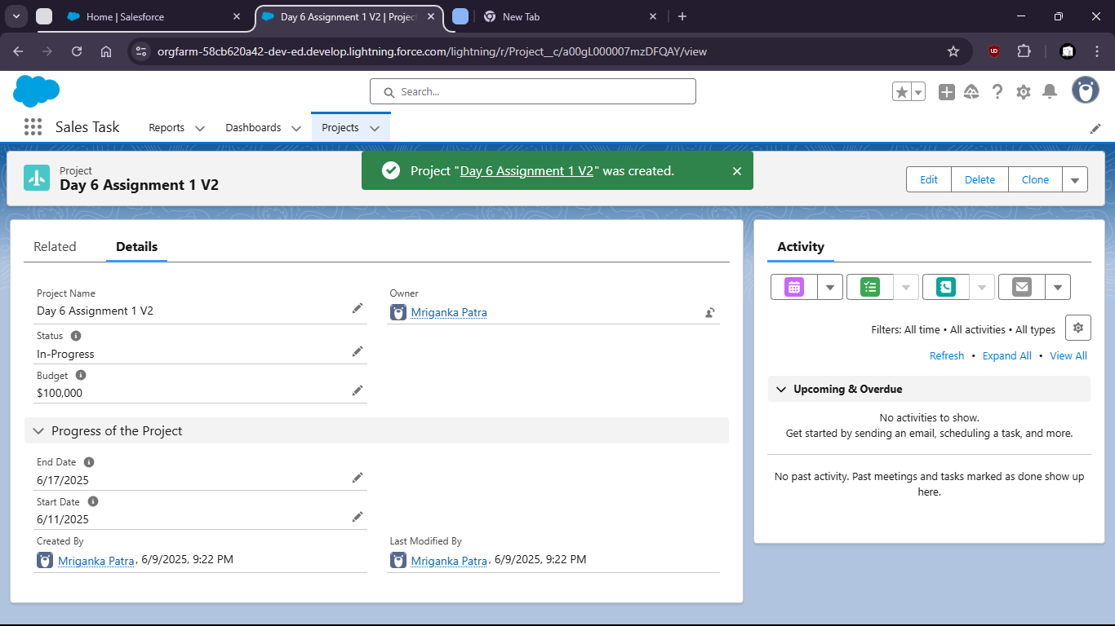

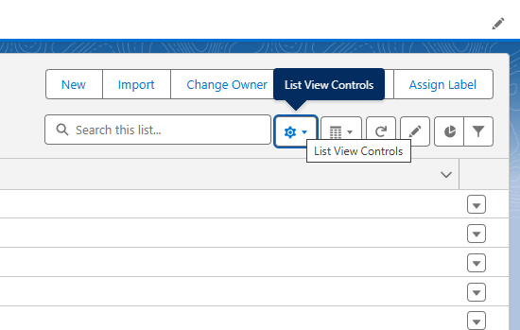

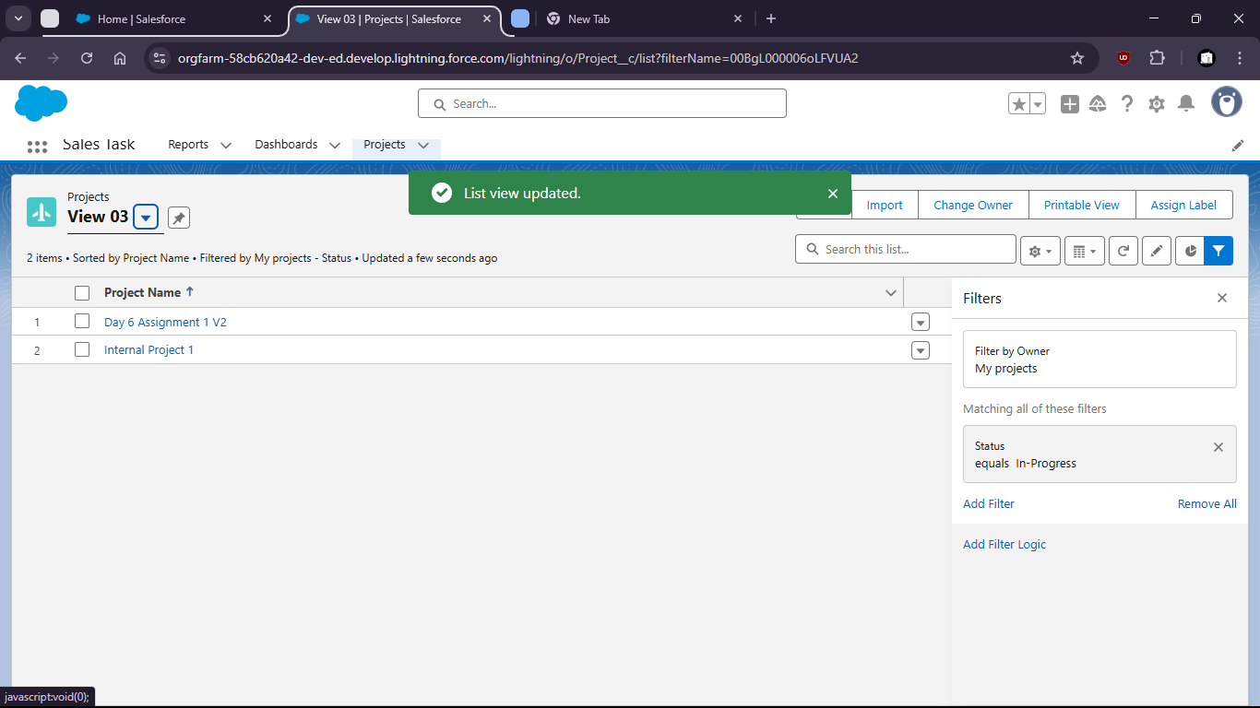

2. Define a workflow process to automatically send an email when a projects status is updated to ‘complete’

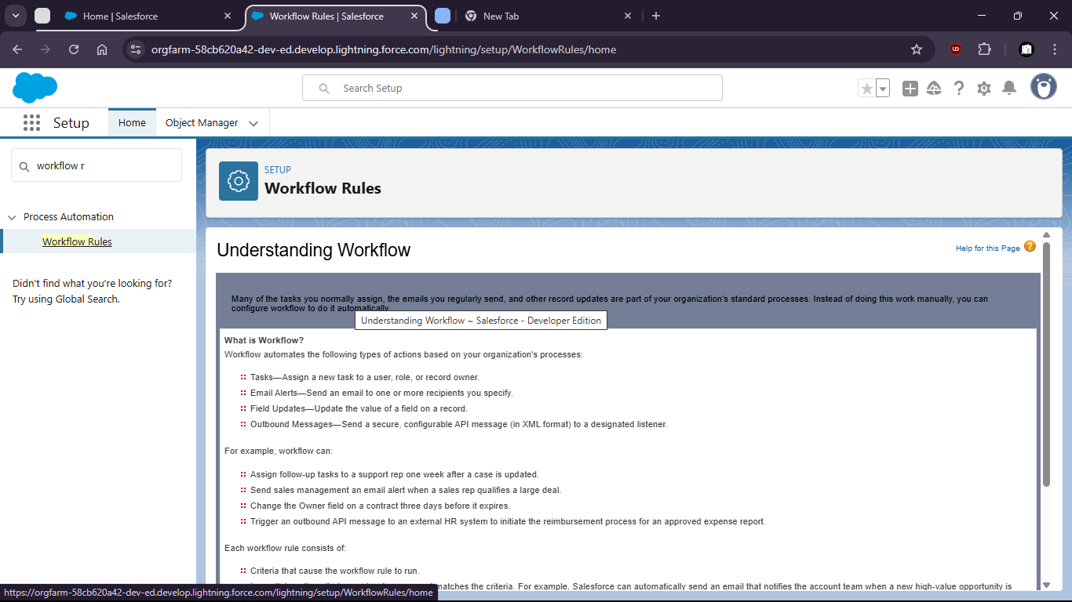

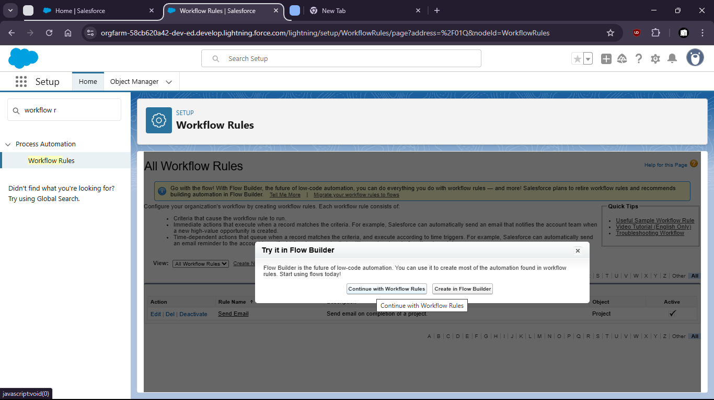

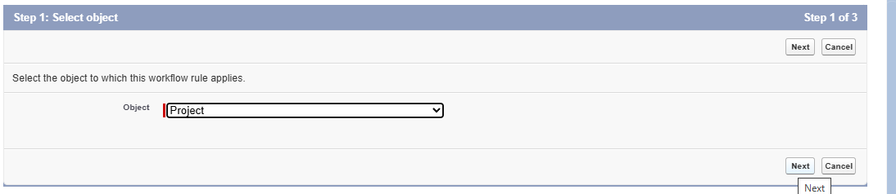

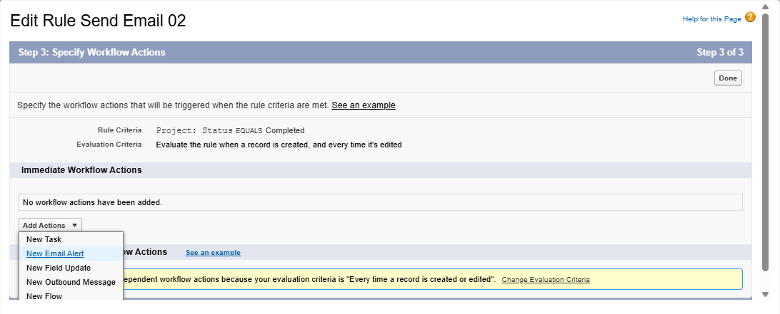

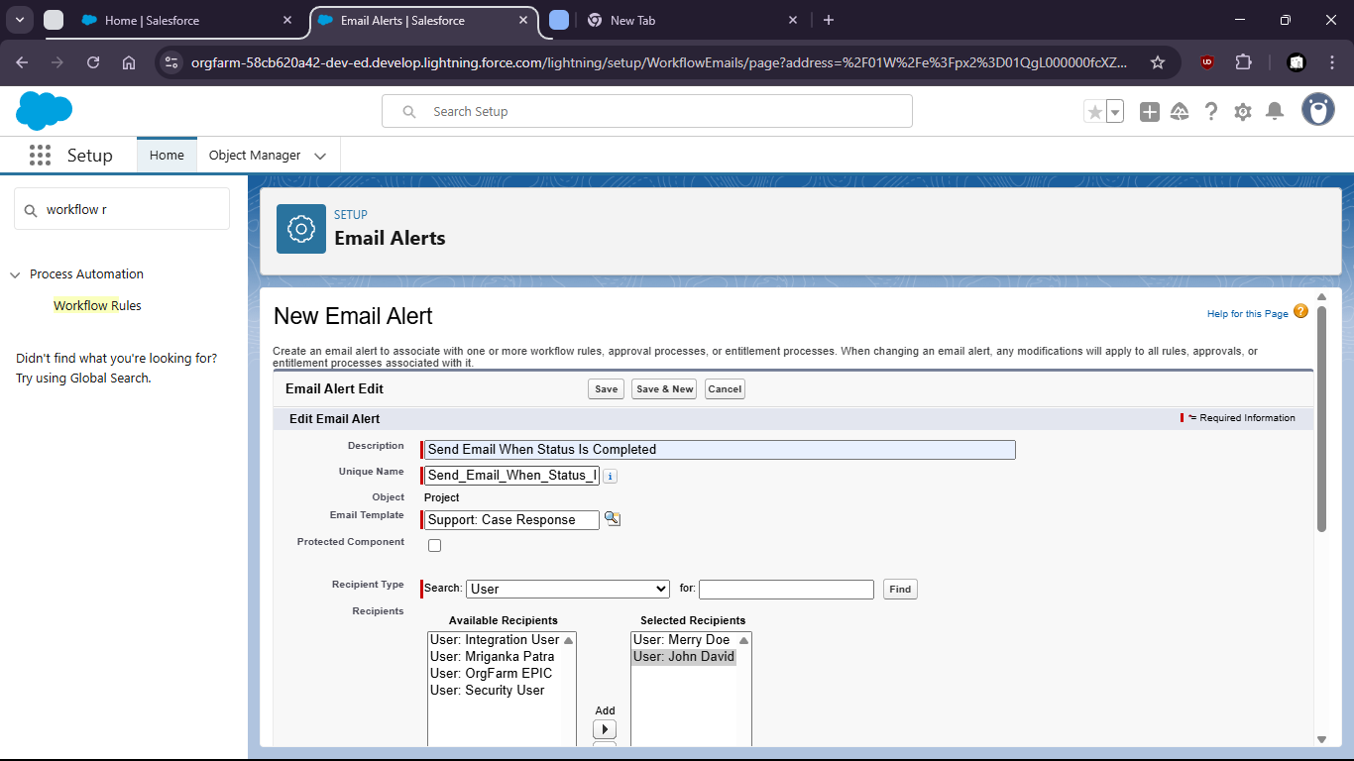

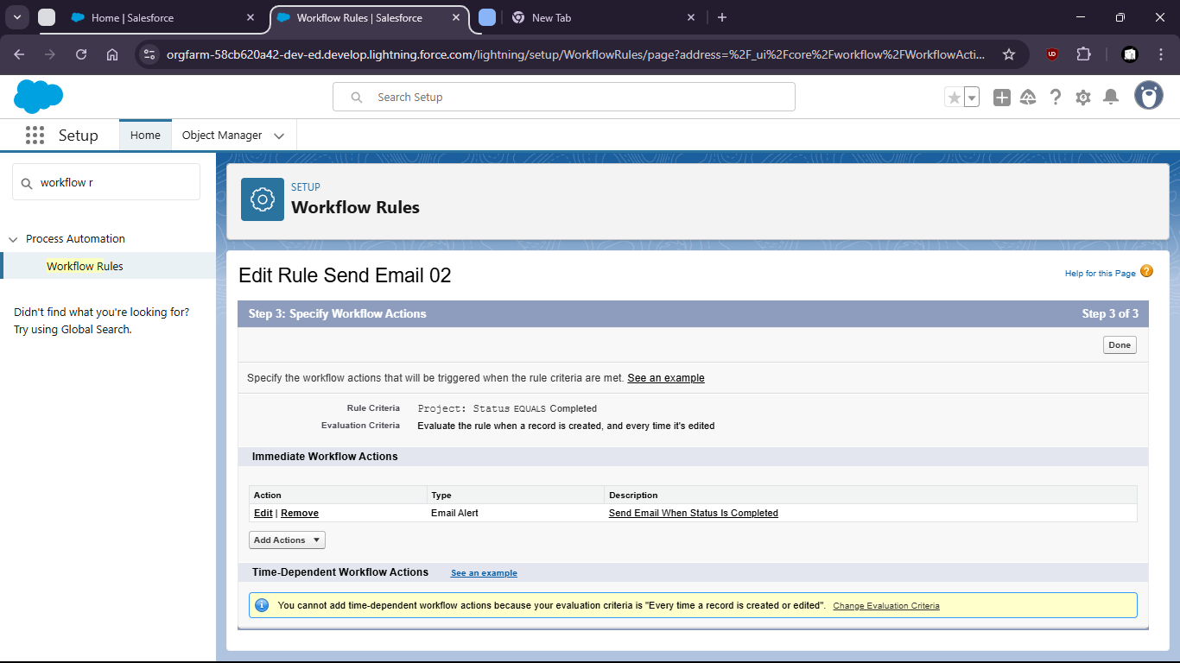

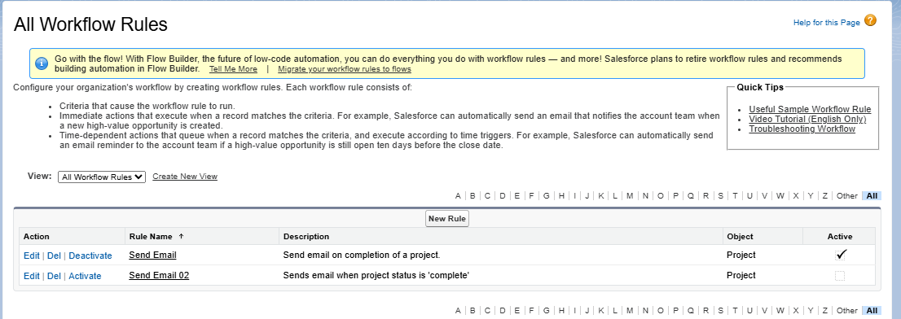

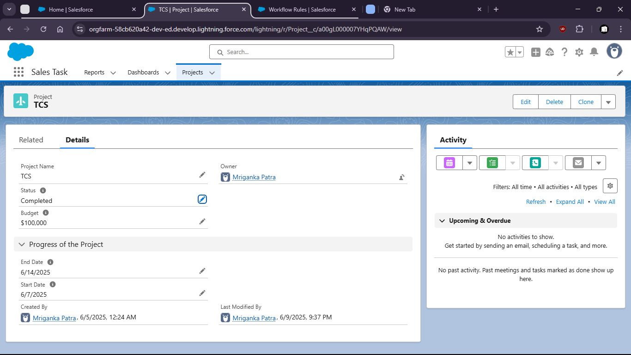

Task 3 : Create a validation rule to ensure ‘End Date’ is always after ‘Start Date’

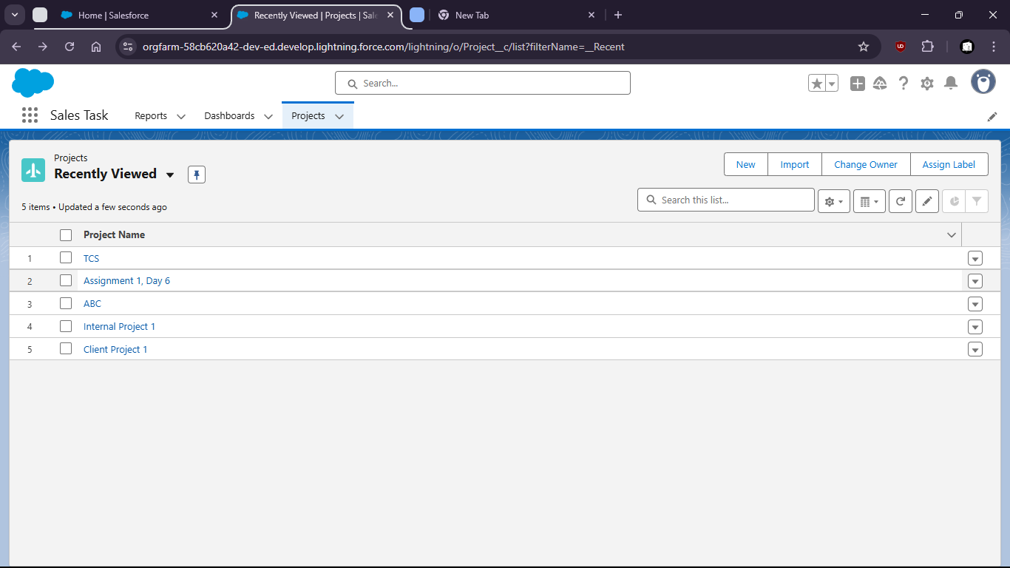

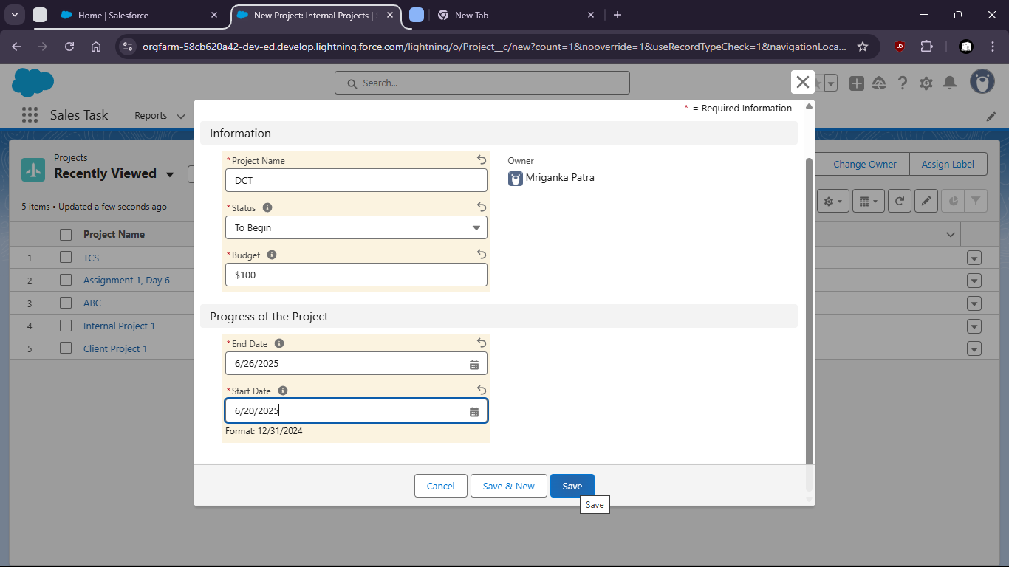

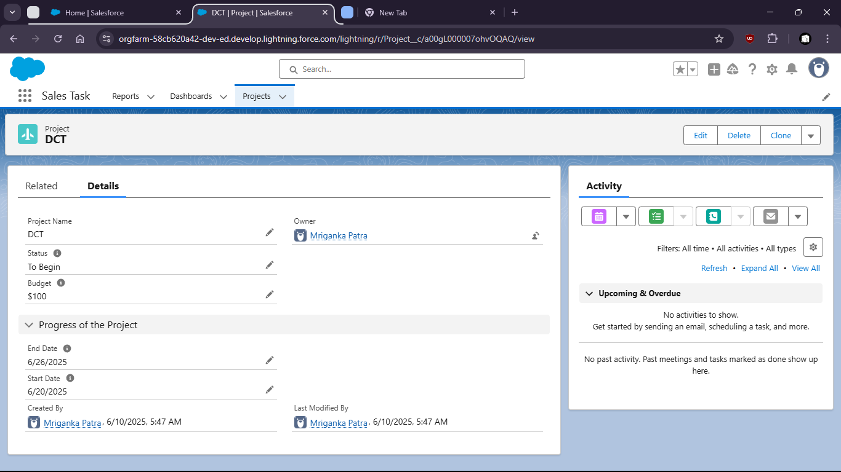

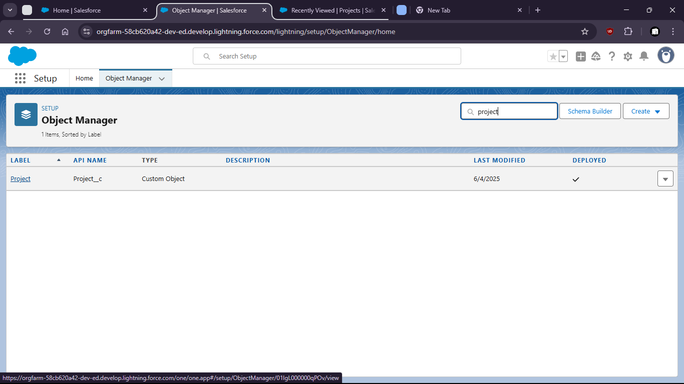

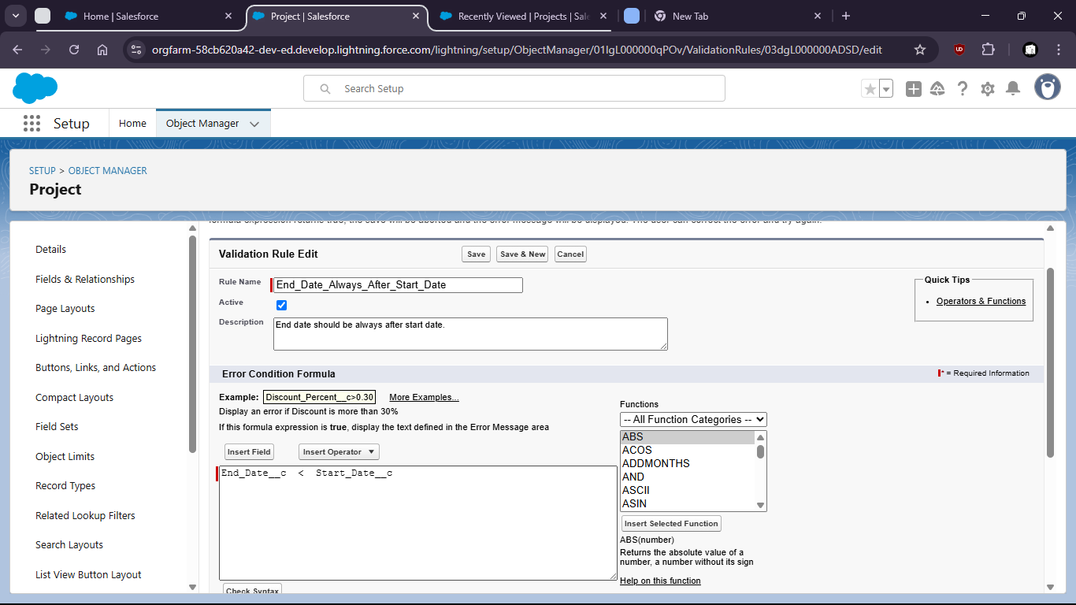

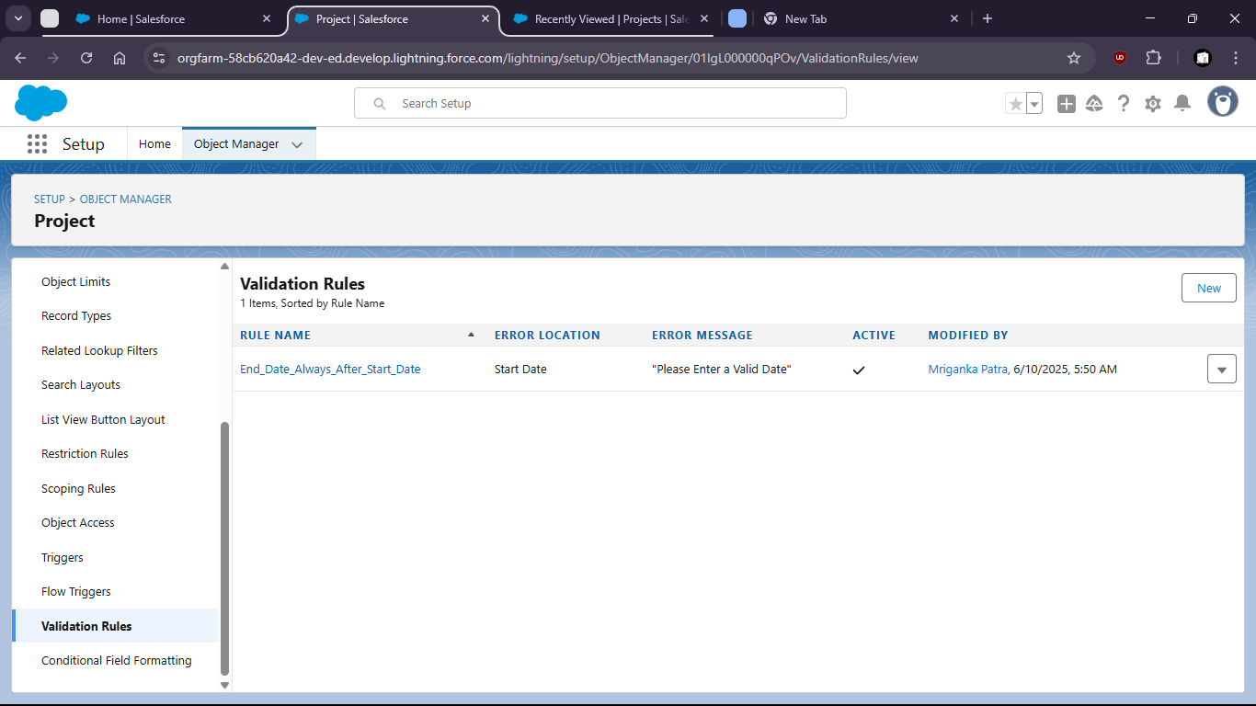

After Setting Rule End data can’t be before Start Date

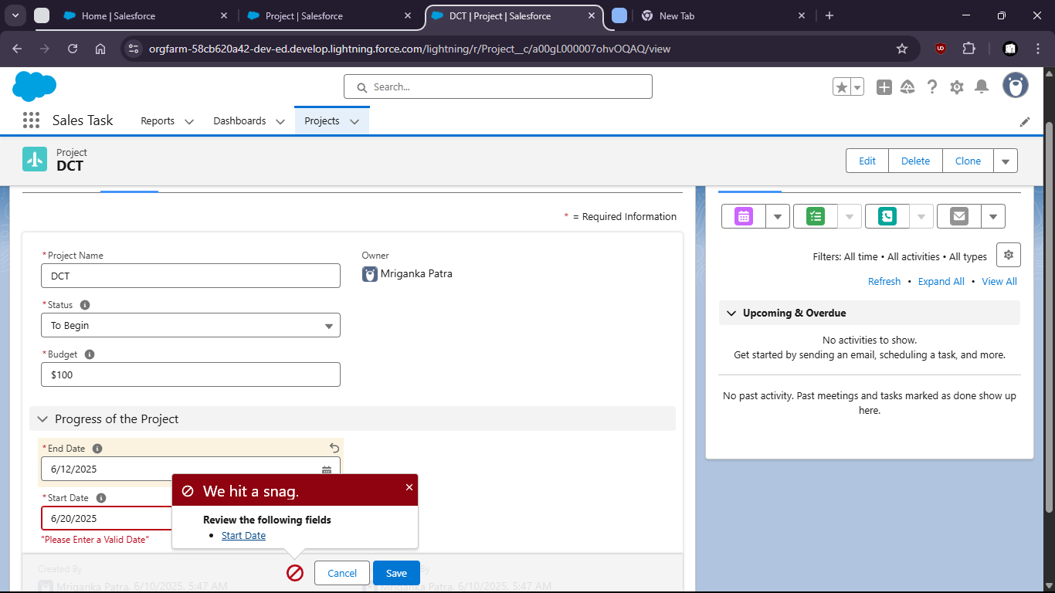

Task 4 : Set field-level security to restrict access to the ‘Budget’ field for a specific profile

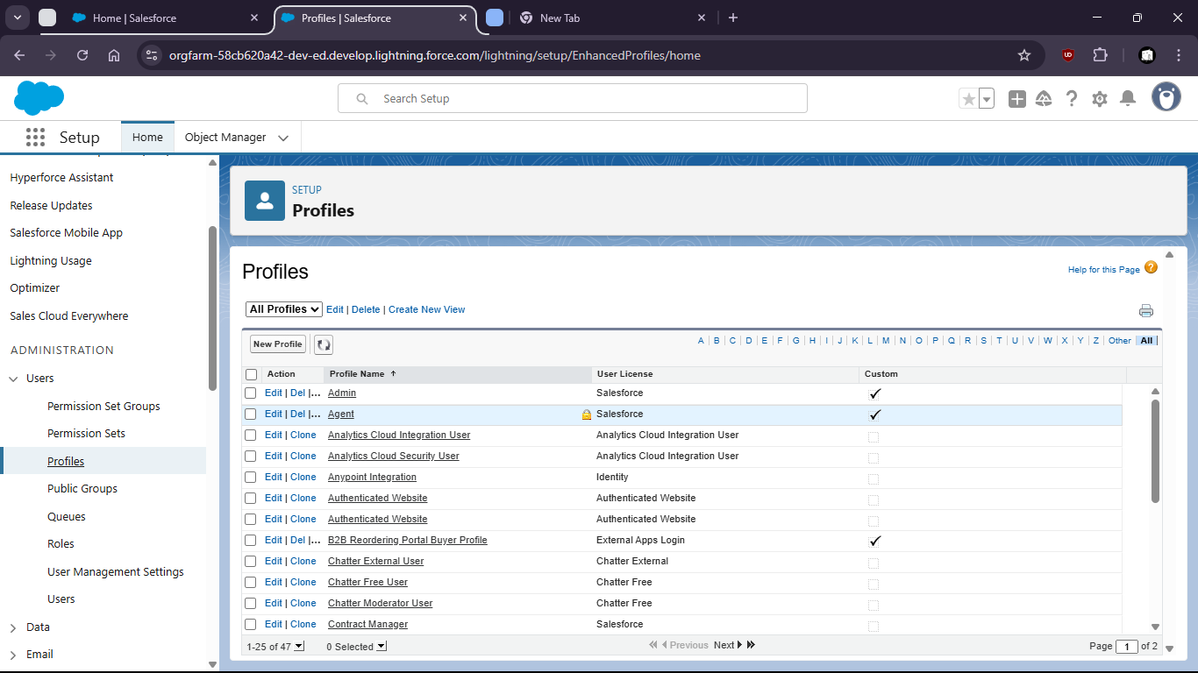

First check for “Project”

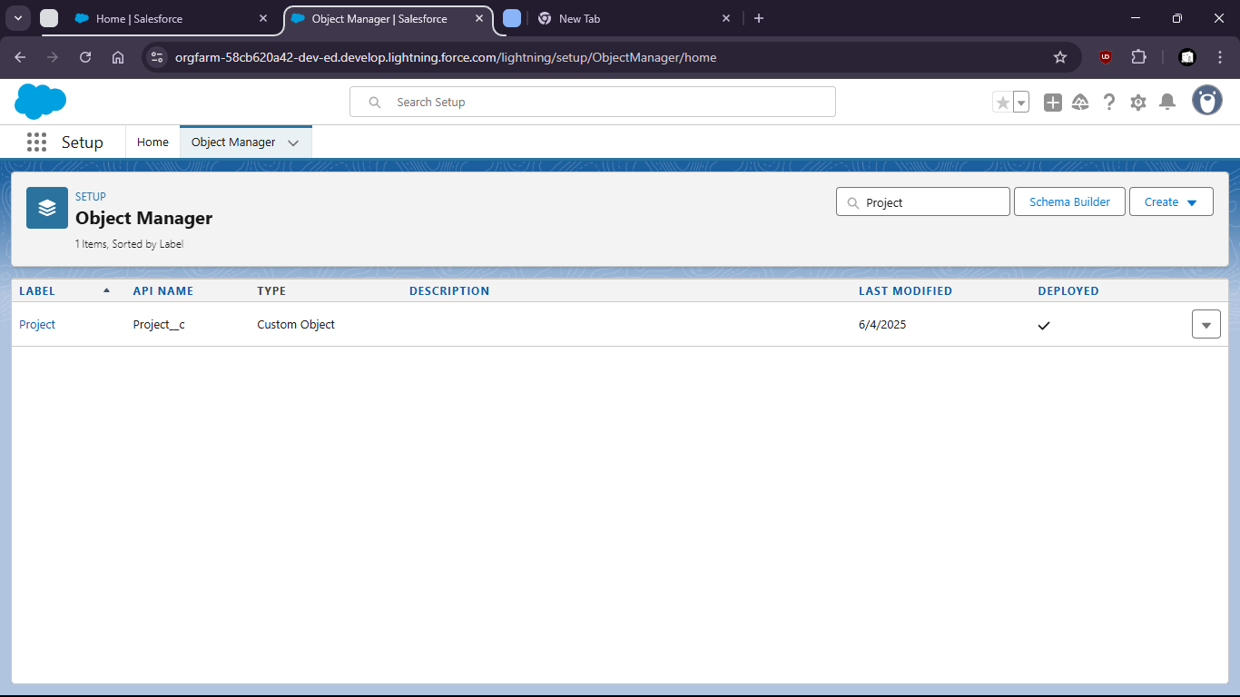

Then create custom field “Budget” if not present. With it being **not always required**.

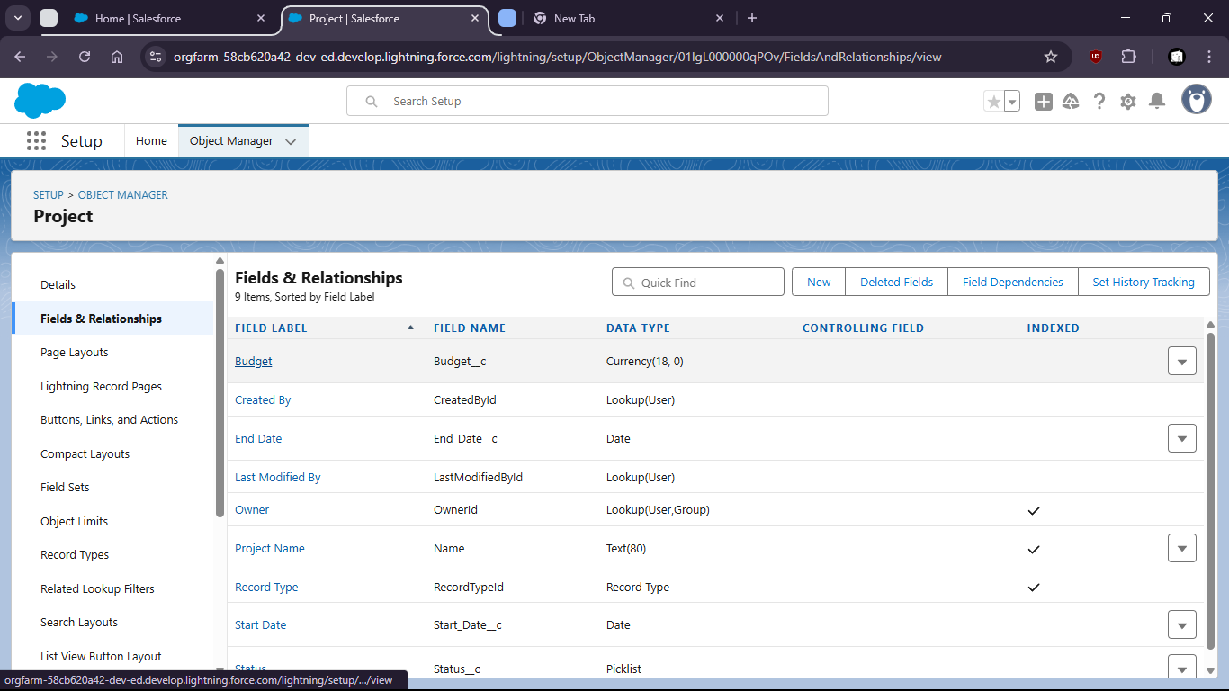

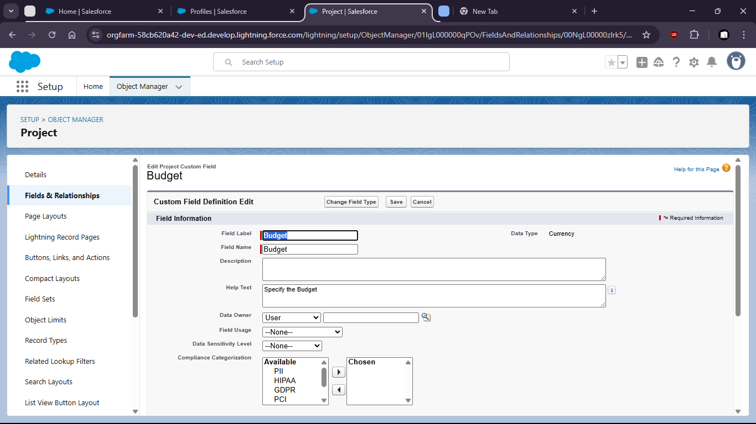

Goto profiles > field level security > Custom Field “Project” [view] > Make Changes

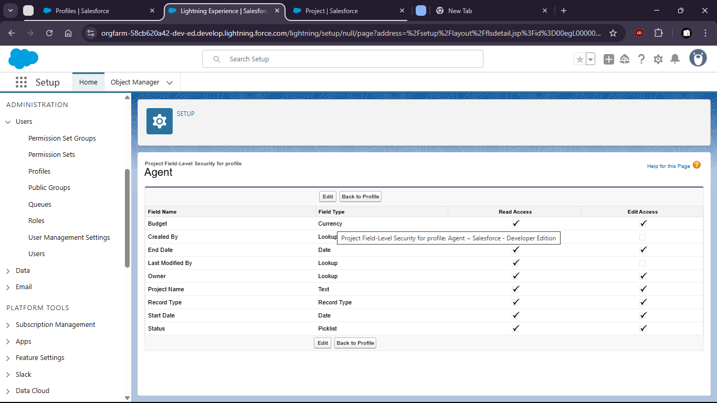

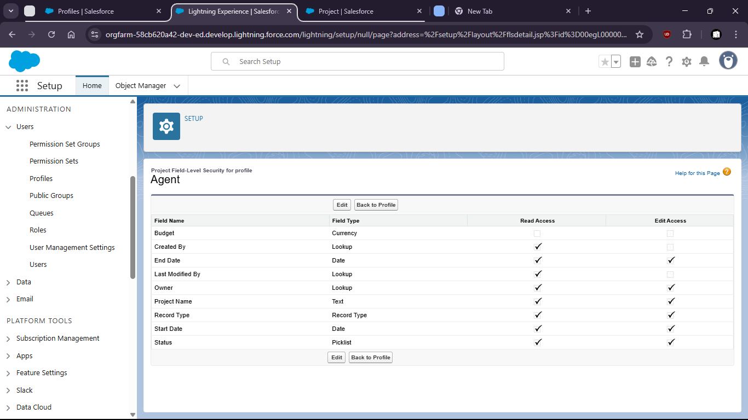

Task 5: Configure Object-level permissions to control create , read and edit rights for the ‘ Project Object’

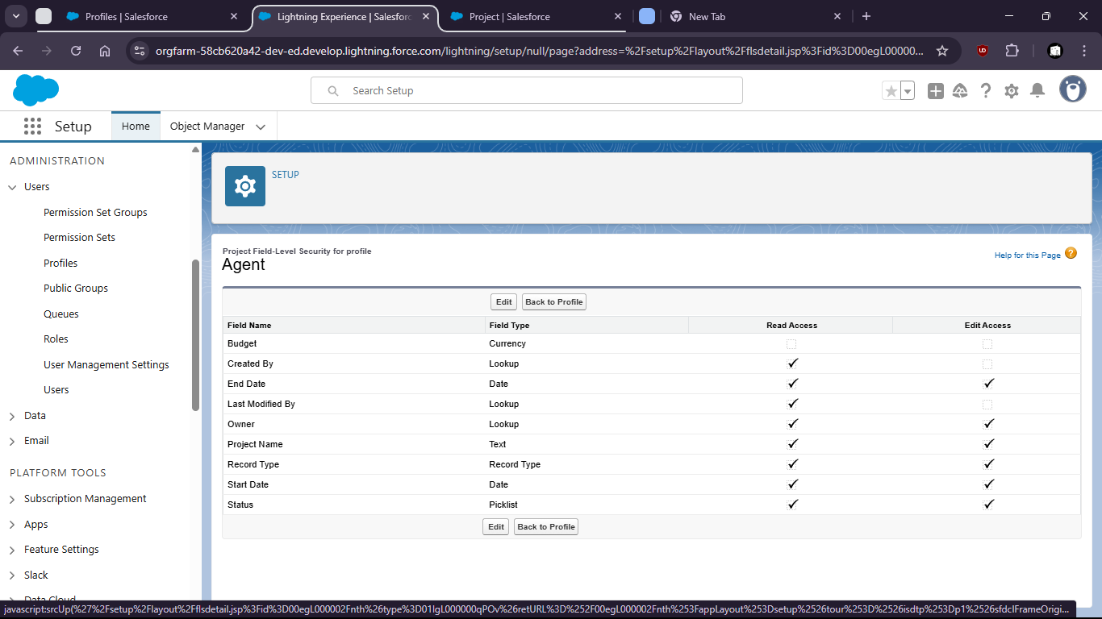

Standard Object Permission

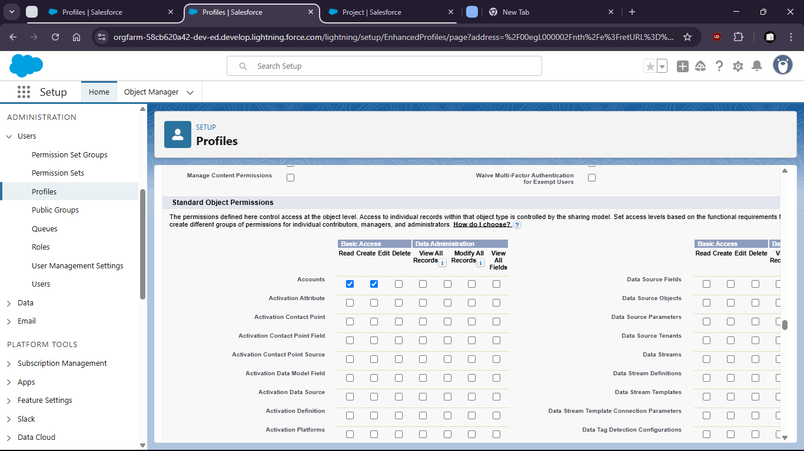

Custom Object Permission

